Tormentil Mining Bee and Nomad Bee Survey Report 2025
Summary
2025 was a relatively productive year for Andrena tarsata, with some good survey results coming out of the stronghold site at Allerthorpe Common and a brand new site for the species being discovered at Harwood Dale, North Yorkshire. In total, the 2025 survey period across yorkshire yielded 100 observations, which is the highest number observed in 6 years of monitoring, with the closest number of observations being 74 in 2023. Audio monitoring was revisited for the 2025 survey period at Allerthorpe Common, this time attempting to use more sensitive devices and implemeting noise cancellation, however this proved to be unsuccessful. The first confirmed observations of Andrena tarsata nesting at Allerthorpe Common were made at one of the intentionally created nesting mounds within the YWT reserve. Unfortunately, there are still no signs of the Nomad Bee (Nomada roberjeotiana) at any of the survey sites.
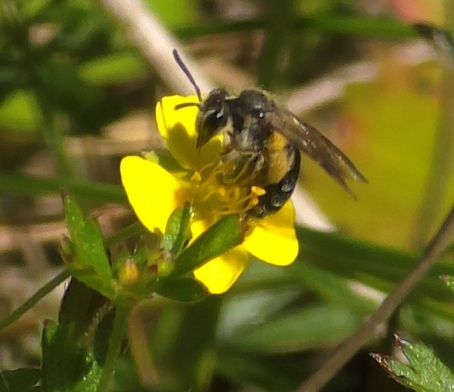
Allerthorpe Common, North Yorkshire
Female Andrena tarsata © Phill Robinson
Survey results from 2025 indicate that the species continues to use the bee track, plus the northern section of the track that intersects with it, as well as wider areas of tormentil habitat within the Yorkshire Wildlife Trust reserve. There remain several opportunities to enhance habitat on Allerthorpe Common, including expanding Tormentil-rich areas by reducing scrub along the bee track through more extensive cutting. Additional nesting habitat could also be created by excavating sandy patches to form open and steep sandy faces, both on the reserve and along the bee track.
Forestry England
The bee track performed reasonably well this year, with several patches of dense Tormentil present. However, gorse and other scrub are significantly encroaching on a number of sections. A substantial programme of scrub removal has therefore been agreed with Forestry England over the winter of 2025/26 to promote improved Tormentil growth in 2026 and hopefully result in an increase in bee numbers.
Yorkshire Wildlife Trust (YWT) reserve
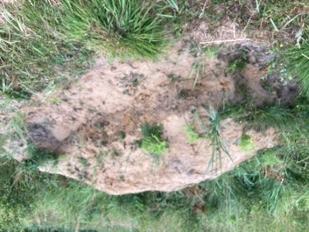
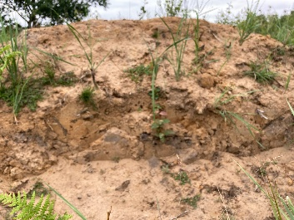
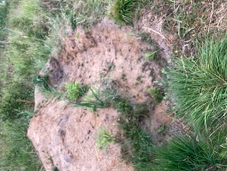
Volunteers from the Yorkshire Wildlife Trust created a new sandy nesting area in early 2025 (see photos below, taken at different angles). Excavation of the site produced a steep, well‑structured sandy face. As a result, three female Andrena tarsata were observed nesting in the area, and three additional females were found dead at the base of the slope, it is likely that they had already nested.
Several angles of the newly created nesting mound, in which species was observed to be nesting © Vicky Wilkins
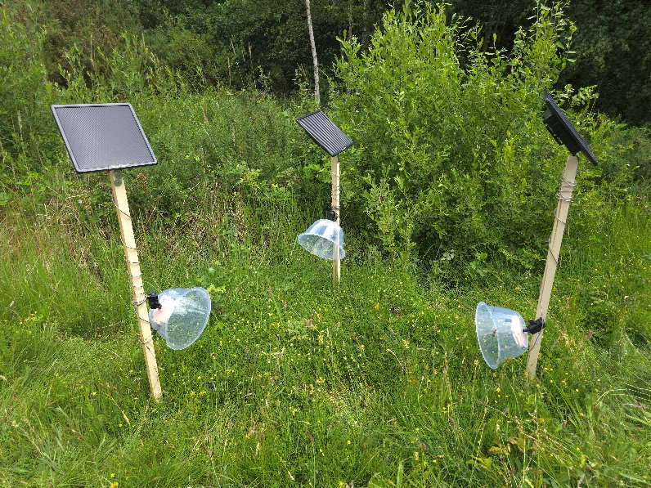
Audio Monitoring
The first phase of the audio monitoring trial, using all 3 devices alongside timed observations in attempt to get a baseline © Phill Robinson
An audio monitoring trial was also carried out at the site in order to explore the potential use of passive species surveys for the Tormentil Mining Bee. However, after some refining and a trial attempting to use modified noise cancellation techniques, the project was unfortunately found to have been unsuccessful as the Bee was too small to allow for detection without issues from background noise.

Allerthorpe Common records for Andrena tarsata
Historic Records | Records 2019 | Records 2021 | Records 2022 | Records 2023 | Records 2024 | Records  2025
Extensive historic records for Andrena tarsata in 1925, 1927, 1928, 1929, 1932, 1973, 1974, 1976, 1979, 1980, 1981, 1983, 1984, 2004, 2005, 2006, 2007, 2008 | About 10 individuals recorded mainly females | 28 individuals recorded in 1 hour spending 30mins each side of the bee track | 8 individuals recorded in 1 hour | 69 bees over 1 hour on track | 9 bees recorded on the bee track via ad hoc observation (transect couldn’t be completed) | A total of 10 bees recorded in the timed transects of 1 hour, a total of 32 records  Alongside these timed transects, ad hoc surveys occurred between 26/6/25 and 10/7/25 which resulted in 50 females and 6 males being observed over 6 surveys.
Extensive historic records for Nomada roberjeotiana in 1927, 1928, 1929, 1935, 1973, 1975, 1976, 1983 | None found | None found | None found | None found | None found | None found

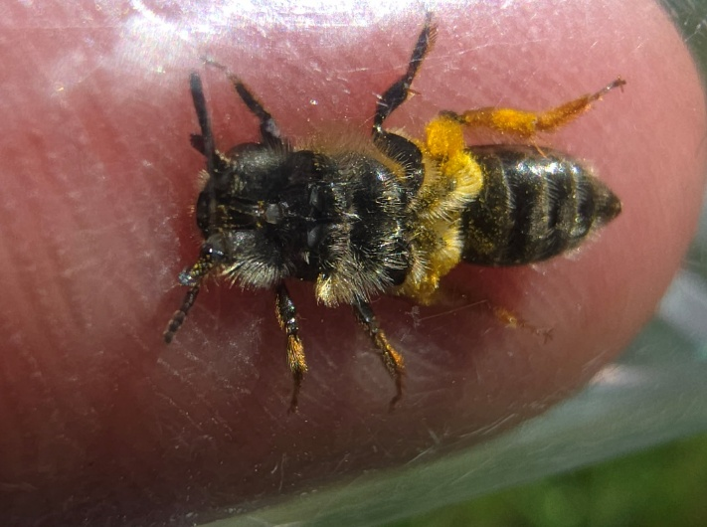
The Tormentil Mining Bee on Harwood Dale
The first confirmed Andrena tarsata at Harwood Dale, being gently restrained in a tube in order to confirm its ID.
In July 2025, after an unsuccessful survey of Jugger Howe, a later afternoon (arriving at around 16:50) survey was conducted at Harwood Dale, whilst being in the area. The conditions were warm and still, with little cloud cover in the sky. Upon walking Southeast down the first logging road ( from SE9536398761) it was noted that there was Tormentil growth on the North side of the track, with some clumps growing to around 1.5m in length. Each Tormentil stand was searched for any Bee activity, however due to the late afternoon, the first 700m of the logging road was in shade and had little in the way of foraging activity.
Results from an initial survey of Harwood Dale for Andrena tarsata
Grid Reference | Number
SE9587798272 | 3 females (also several A. subopaca)
SE9587798268 | 2 females
SE9593298165 | 3 females (also several A. subopaca)

Strensall Military Training Ground, North Yorkshire
Unfortunately, surveys over six years between 2019-2024 have not recorded Andrena tarsata nor its nomad bee at Strensall Common/Military Training Ground. It was last recorded in 2008 and its nomad bee in 2009. It is likely that the species is no longer on site due to sheep grazing on the heath edges, restricting the flowering level of Tormentil, combined with limited access to open sandy areas.
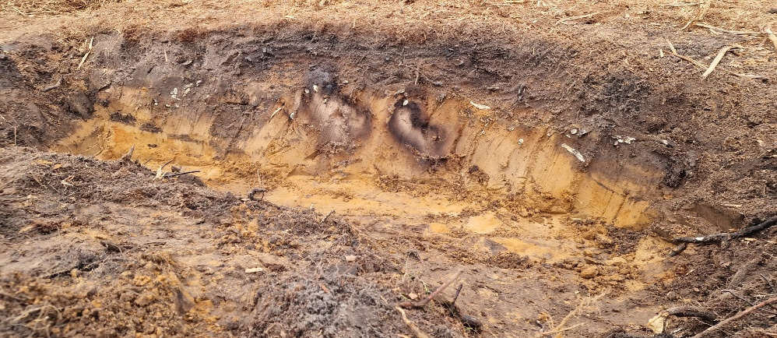
The creation of open sandy areas on the Yorkshire Wildlife Trust area in 2024 of the common (see photo below), did result in early nesting mining bees using the site in early 2025. However, by the summer of 2025 the site had unfortunately been taken over by bracken again.
An open sandy bank created as an intentional nesting are for Andrena tarsata © Vicky Wilkins
Pampledale Moor, Cod Beck Reservoir, North Yorkshire
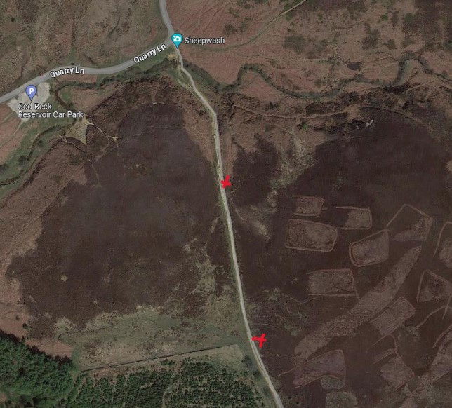
In 2025, the Tormentil mining bee Andrena tarsata was again recorded at Pampledale Moor, observed flying on Tormentil flowers during fine July weather. Further details of these records are provided below.
A satelite image depicting the transect in which the bee records have been observed, these were mostly the east side of track and more to the northern end between the two crosses

Andrena tarsata at Pampledale Moor continues to use the main track, running from the ford on the beck (sheep wash) up to the edge of the conifer plantation. This pattern is consistent with all other observations, with the occupied area marked by two crosses on the east side of the track in the photo.

Pampledale Moor records of Andrena tarsata
Historic Records | Records 2019 | Records 2021 | Records 2022 | Records 2023 | Records 2024 | Records 2025
First recorded in 2011, possible that the site was overlooked previously | 5 females recorded on taller tormentil found further into the site | 2 females were recorded plus 1 male, the numbers weren’t as high on the site in 2021 | No records | 5 bees, 4 females plus 1 male | 2 bees, both female | 4 female bees

Jugger Howe, Flyingdales, North Yorkshire
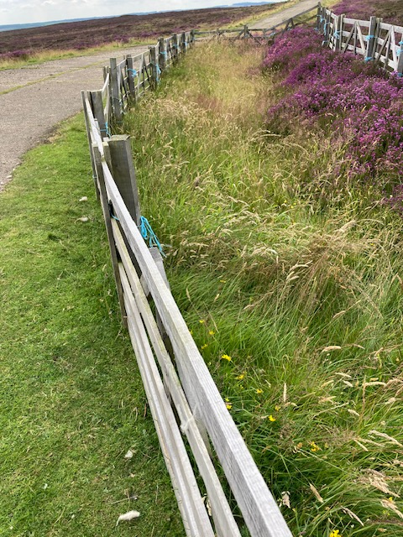
At Jugger Howe unfortunately again in 2025 we did not manage to record the species, this means the species has not been recorded for three years sequentially. The Tormentil was in the right condition for the bee on the bee mounds due to the ongoing gorse removal and also in the sheep hurdled area.
A pen set up to prevent grazing of Tormentil at an area of Jugger Howe that has had confirmed Andrena tarsata observations in previous years (c) Vicky Wilkins

Jugger Howe records for Andrena tarsata
Historic Records | Records 2019 | Records 2020 | Records  2021 | Records 2022 | Records 2023 | Records 2024 | Records  2025
First recorded from this site in 2010 were on the main site, it is possible that before 2010 this species was present but overlooked. | 1 female Andrena tarsata  found on bee mounds, although a number of individual were seen | In 2020 I again found a single female on the bee mounds in the car park | Not recorded | 1 female found on bee mounds, see map 1 for location | Not recorded | Not recorded | Not recorded

Conclusion
Although there have been no observations made for another year at several historic sites, the numbers observed at sites in which the species is present have increased, with numbers observed at their stronghold site, Allerthorpe Common, almost recovering to their 2023 survey numbers after a poor 2024. Alongside this, the species being discovered at Harwood Dale may also present a new opportunity for the rediscovery of Nomada roberjeotiana within Yorkshire when this site receives more focus in 2026. Finally, although audio monitoring at Allerthorpe Common proved unsuccessful for a second attempt, the time allocation that this trail utilised can be repurposed into visual surveys for the 2026 year, in hope to see further increases in numbers and confirmed observations of nesting.

